NADAR SARASWATHI COLLEGE OF ENGINEERING AND TECHNOLOGY

DEPARTMENT OF ELECTRICAL AND ELECTRONICS ENGINEERING

E-FANZINE

VOL.1ISSUE:9
JULY2021

CONTENTS

COLLEGE VISION MISSION
DEPARTMENTVISIONMISSION
STAFFACTIVITY

EDITORIALBOARD

VOL.NO:1ISSUE8/JUNE2021

VISIONOFNSCET
Place for Technology Revolution

MISSIONOFNSCET
Promote and undertake all-inclusive developments.(Vision)
Develop high-qualitytechnicaleducationwithacademicexcellenceandinnovativeresearchwithethics. (TLP)
Createanatmospherewhereteacherenjoys facilitationandlearners(students)enjoylearning through fosterinnovation. (PEO&PSO)
Collaboratewithindustryandacademictomeet thechangingneedsofsociety. (POAttainment)

VISION
Emergeasavaluableglobalresourceforpowersectorandconsumerelectronics
MISSION
- Establishthecognitiveandeffectivedomainsof studentsthroughappropriateteaching-learningprocessandindustry-instituteinteractions.
- Executeprojectswithintegrityandethics keepingpacewiththelatesttrendsinpowerelectronics industry.
- Developenergytechnologypartto handlevarious sustainabilitychallengesofthesociety.
- Upgrade the knowledgeandskillsoffacultythroughqualityimprovementprograms.

FromtheHODdesk

Goodday,everybody.

Greetings!!!FromThedepartmentofElectricalandElectronicsEngineering of NSCET. The department of EEE is one of the oldest engineeringdepartments which Enlightens any other engineering discipline. Can you Hinkof a minute without ELECTRICAL POWER? NO, We can’t. The cross-countrypower transmission lines, household lights, and motors to name the very fewarethebestexamplesillustratingthis.We,Heelectricalengineershavecreateda great infrastructure in which the world runs on top of it. We will also createthefuture.WIRELESSPOWERTRANSFER,SOLARPOWER,ELECTRICAL
VEHICLES,tonameafew.ThefutureisOURs.
WededicateE-FANZINE,tothestudents’fraternityoftheEEEdepartmentof our institution. Students can actively do a variety of activities which takesthemtowardsbecominganindustryleader.Alloftheseactivitiescanbedocumented in this newsletter. This newsletter is monthly where any studentandfacultycancontributetoit.Iwishallthestudentsandfacultymakefulluseofitandagrandsuccess.

M.ArivalaganHOD/EEE.

VOL.NO:1ISSUE8/JUNE2021

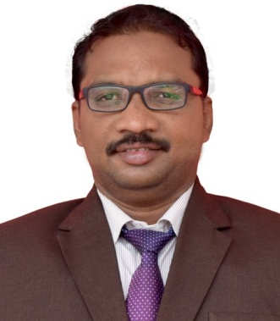
Mr. ARIVALAGAM
HOD/EEE

He actively Participated in the webinar on “Power system analysis” organizedbyIIT Kharagpur on 23rd July 2021.

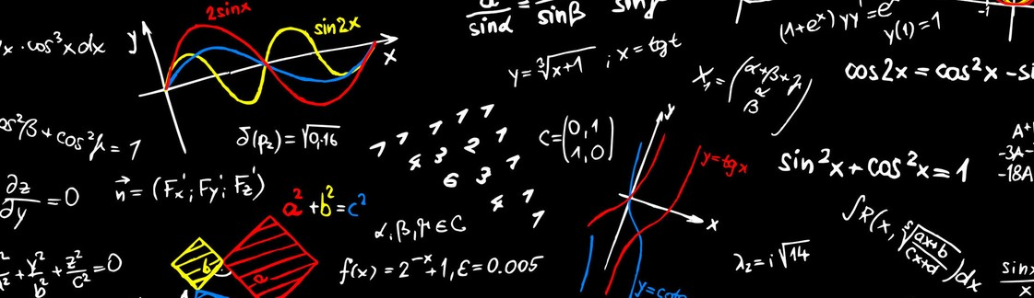
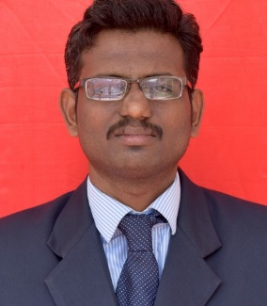
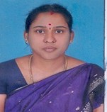
MS. K. MALAR
AP/EEE

She actively Participated in the webinar on “Challenges in integration of renewable energy sources in smart grid” organizedbyDepartment of Electrical and Electronics Engineering, Dr. Mahalingam college of engineering and Technology, Pollachi on 3th July 2021.

She actively Participated in the webinar on “Power system protection in smart grid environment” organizedbyDepartment of Electrical and Electronics Engineering, Dr. Mahalingam college of engineering and Technology, Pollachi on 6th July 2021.

Shehasparticipatedin the five days online short-termprogramonpeer to peer energy transaction in smart distribution systems ,organized by Vellore Institute of Technology with AICTE training and learning (ATAL) Academic online FDP on from 26th July 2021 to 30th July 2021.

Shehasparticipatedin the five days online short-termprogramonSmart grid and sustainable energy management in virtual power plant ,organized by school of Electrical and electronics Engineering and Department ofElectrical and electronics Engineering, Sathiyabama institute of science and technology on from 26th July 2021 to 30th July 2021

Mr. K. GANESH
AP/EEE

He actively Participated in the webinar on “Challenges in integration of renewable energy sources in smart grid” organizedbyDepartment of Electrical and Electronics Engineering, Dr. Mahalingam college of engineering and Technology, Pollachi on 3th July 2021.

He actively Participated in the webinar on “Power system protection in smart grid environment” organizedbyDepartment of Electrical and Electronics Engineering, Dr. Mahalingam college of engineering and Technology, Pollachi on 6th July 2021.

Hehasparticipatedin the five daysonline short-termprogramonpeer to peer energy transaction in smart distribution systems ,organized by Vellore Institute of Technology with AICTE training and learning (ATAL)Academic online FDP on from 26th July 2021 to 30th July 2021.

Hehasparticipatedin the five days online short-termprogramonSmart grid and sustainable energy management in virtual power plant ,organized by school of Electrical and electronics Engineering and Department ofElectrical and electronics Engineering, Sathiyabama institute of science and technology on from 26th July 2021 to 30th July 2021.

.

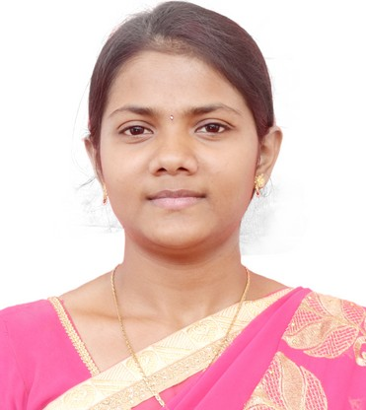

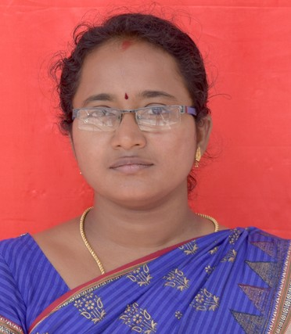

MS.B.SHANHINI

AP/EEE

WEBINAR:
She actively Participated in the webinar on “Challenges in integration of renewable energy sources in smart grid” organizedbyDepartment of Electrical and Electronics Engineering, Dr. Mahalingam college of engineering and Technology, Pollachi on 3th July 2021.

Shehasparticipatedin the five days online short-termprogramonpeer to peer energy transaction in smart distribution systems ,organized by Vellore Institute of Technology with AICTE training and learning (ATAL) Academic online FDP on from 26th July 2021 to 30th July 2021.

MS.M.DIVYABHARATHI

AP/EEE

WEBINAR:
She actively Participated in the webinar on “Power system protection in smart grid environment” organizedbyDepartment of Electrical and Electronics Engineering, Dr. Mahalingam college of engineering and Technology, Pollachi on 6th July 2021.

Shehasparticipatedin the five days online short-termprogramonSmart grid and sustainable energy management in virtual power plant ,organized by school of Electrical and electronics Engineering and Department ofElectrical and electronics Engineering, Sathiyabama institute of science and technology on from 26th July 2021 to 30th July 2021.

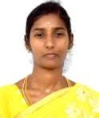

MRS.R.CHITRA

AP/EEE

WEBINAR:
She actively Participated in the webinar on “Power system protection in smart grid environment” organizedbyDepartment of Electrical and Electronics Engineering, Dr. Mahalingam college of engineering and Technology, Pollachi on 6th July 2021.

Shehasparticipatedin the five days online short-termprogramonSmart grid and sustainable energy management in virtual power plant ,organized by school of Electrical and electronics Engineering and Department ofElectrical and electronics Engineering, Sathiyabama institute of science and technology on from 26th July 2021 to 30th July 2021.

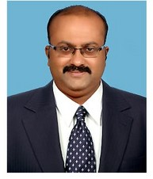

Dr. M. PANDIMAHARAJAN

ASSOSIATE PROFESSOR/EEE

WEBINAR:
He actively Participated in the webinar on “Recent trend in EV technology” organizedbyDepartment of Electrical and Electronics Engineering, DME college of engineering and Technology, Chennai on 9th July 2021.

Hehasparticipatedin the five days online short-termprogramonSmart grid and sustainable energy management in virtual power plant ,organized by school of Electrical and electronics Engineering and Department ofElectrical and electronics Engineering, Sathiyabama institute of science and technology on from 26th July 2021 to 30th July 2021.

Mr. N. RATHINAVEL SUBRAMANIAN

AP/EEE

He actively Participated in the webinar on “Power system protection in smart grid environment” organizedbyDepartment of Electrical and Electronics Engineering, Dr. Mahalingam college of engineering and Technology, Pollachi on 6th July 2021.

Hehasparticipatedin the five days online short-termprogramonSmart grid and sustainable energy management in virtual power plant ,organized by school of Electrical and electronics Engineering and Department ofElectrical and electronics Engineering, Sathiyabama institute of science and technology on from 26th July 2021 to 30th July 2021.

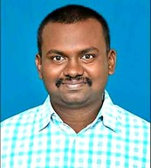

Mr. S. RAHUL SOMNAATH

AP/EEE

He actively Participated in the webinar on “Challenges in integration of renewable energy sources in smart grid” organizedbyDepartment of Electrical and Electronics Engineering, Dr. Mahalingam college of engineering and Technology, Pollachi on 3th July 2021.

Hehasparticipatedin the five days online short-termprogramonpeer to peer energy transaction in smart distribution systems ,organized by Vellore Institute of Technology with AICTE training and learning (ATAL) Academic online FDP on from 26th July 2021 to 30th July 2021.

PLACEMENT
ACTIVITIES

Ourdepartmentstudents Dinesh Kumar. Sand Pavusal Mubarak. S placedinthe SYNERGY Groups.,
In July,wehavedeliveredthetechnical,Aptitude,CurrentAffairs,andCommunicationContentsareSharedtothestudent, and also, we conducted He weekly quiz based on theirrespectivetopics.

EDITORIALBOARD

Editorin Chief
Mr.M.ArivalaganHOD/EEE

Editor
Mr.S.RahulSomnathAP/EEE

Design team
Ms.M.DivyaBharathiAP/EEE
Studentmembers
- AisswaryaLaksmi.M
- Abinayadevi
- Nisha.V
- Senthamilan.S
- ShanmugaPandian.M
- Sutharsan.T
- Sundharamagalingam.M

VOL.NO:1ISSUE9/JULY2021

